**Project Name:** Car Racing Game

**Project Group Members:**

* Buğra Furkan Karabulut 21427047
* Utku Sarı 21527299
* Baran Bursalı 21526786

**Short Description of the Project:**

A car racing game which controls one players' car and races with CPU-controlled bots on a given track. Basic goal of the game is keeping the users' car on the race path of the track area for longest time and for fastest speed also. Simply winning the race, defeating bots.

**Visual drafts:**

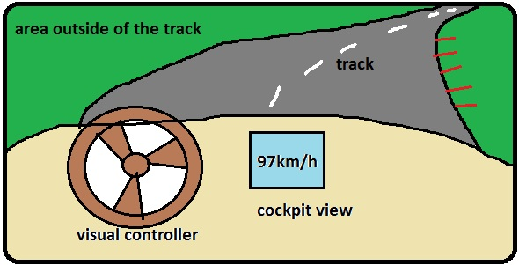

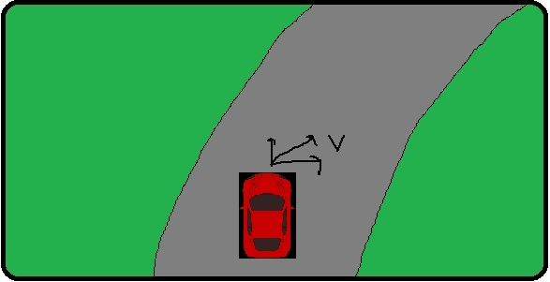

**Detailed Project Proposal:**

Main thing of this project is players’ car and its interaction with the environment and the player. The environment consist of two main components. These are the bots and the map.

**Bots:** The difficulty and the number of bots can be selected by the player before the race starts. The number of bots will be up to three and each one will have a certain route. The difficulties of the bots will be directly proportional to the initial velocity vectors.

**Map:** The map will consist of the track, the area outside of the track and the sky. As seen in visual drafts, the vehicle will be on this track. Areas outside the track will be designed to increase in-game visuality and to provide the player with a more realistic racing experience. Pre-made models also will be used when designing these areas. The sky will provide the creation of light and shadow movements through the sun. Of course, having a sky and a variable light situation will increase in-game realism.

**Controls and Game Mechanics:**

**Controls:** In the game, the car will move with the player's keyboard using the [W, A, S, D] or up and down left and right keys. W or up key will accelerate the car by increasing the speed vector of the car. S or down key will slow down the car by reducing the speed vector of the car. [A, D] or left and right keys will change the direction vector of the car and it will provide orientation on the track.

**Game Mechanics:** In the game, when the player leaves the track or strikes another vehicle, he will pause for 1-2 seconds, then he will be ready to move again in the direction of the race and at the point where he collides.

There will be three optional camera angles in the game and in fact every angle will affect the gameplay a bit. The player will be able to switch between these camera angles while racing. The player will be able to see the road **in the car** and the **hood-top** camera angles. It will be more convenient to control the vehicle as it can also see the off-track and other vehicles from the **top view point**. In all three cases, daylight and off-track factors will affect the view.